Project Planning Phase

**Project Planning Template (Product Backlog, Sprint Planning, Stories, Story points)**

|  |  |
| --- | --- |
| Date | 22 October 2023 |
| Team ID | NM2023TMID07243 |
| Project Name | Leveraging Data Analysis For Optimal Marketing |
| Maximum Marks | 8 Marks |

# Product Backlog, Sprint Schedule, and Estimation (4 Marks)

|  |  |  |  |  |
| --- | --- | --- | --- | --- |
| **Sno** | **Title** | **Member Names** | **Description** | **Date** |
| 1 | Sprint 1 | TEYJUSWINI | Data Collection and Ingestion | Sep 17 - Sep 20,  2023 |
| 2 | Sprint 2 | KAVITHA | Data Processing and Analysis | Sep 21 - Sep 25,  2023 |
| 3 | Sprint 3 | ABHINAYA | User Interface Design and Visualization | Sep 26 - Sep 29,  2023 |
| 4 | Sprint 4 | RITHIK | Data Integration and Framework Modeling | Oct 1 - Oct 6,  2023 |
| 5 | Sprint 5 | TEYJUSWINI | User Authentication and Security | Oct 8 - Oct 14,  2023 |
| 6 | Sprint 6 | RITHIK | Reporting and Dashboard Development | Oct 15 - Oct 18,  2023 |
| 7 | Sprint 7 | ABHINAYA | Testing and Quality Assurance | Oct 19 - Oct 20,  2023 |
| 8 | Sprint 8 | KAVITHA | Deployment and Release | Oct 21 - Oct 22,  2023 |

|  |  |  |  |  |  |  |
| --- | --- | --- | --- | --- | --- | --- |
| **Sprint** | **Functional Requirement (Epic)** | **User Story Number** | **User Story / Task** | **Story Points** | **Priority** | **Team Members** |
| **Sprint 1** | **Data Collection** | **US001** | **As a Marketing Manager, I want to access IBM Cognos Analytics to collect data for campaign analysis.** | **5** | **High** | **TEYJUSWINI** |
|  | **Data Integration** | **US002** | **As a Data Analyst, I want to integrate data from various sources into IBM Db2.** | **8** | **High** | **KAVITHA** |
|  | **Data Security** | **US003** | **As an IT Specialist, I want to ensure secure**  **data access and encryption during integration.** | **5** | **High** | **ABHINAYA** |
| **Sprint 2** | **Data Transformation** | **US004** | **As a Data Analyst, I want to clean and transform data for accurate analysis.** | **8** | **High** | **RITHIK** |
|  | **Data Analysis** | **US005** | **As a Data Analyst, I want to use IBM Cognos Analytics to analyze marketing campaign**  **data.** | **8** | **High** | **TEYJUSWINI** |
|  | **Data Visualization** | **US006** | **As a Data Analyst, I want to create data**  **visualizations to represent campaign insights.** | **5** | **High** | **TEYJUSWINI** |
| **Sprint 3** | **Data Presentation** | **US007** | **As a Marketing Manager, I want to view dashboards with campaign insights and**  **trends.** | **3** | **High** | **KAVITHA** |
|  | **Decision-Making** | **US008** | **As a Marketing Manager, I want to make data-**  **informed decisions for campaign optimization.** | **5** | **High** | **ABHINAYA** |
|  | **Compliance and Privacy** | **US009** | **As a Compliance Officer, I want to ensure GDPR compliance in data handling.** | **5** | **High** | **RITHIK** |
| **Sprint 4** | **Budget Optimization** | **US010** | **As a Finance Team member, I want to use**  **data insights to optimize campaign budgets.** | **8** | **Medium** | **TEYJUSWINI** |
|  | **Customer Feedback Analysis** | **US011** | **As a Customer Support representative, I want**  **to analyze customer feedback data.** | **5** | **Medium** | **RITHIK** |
|  | **Real-Time Insights** | **US012** | **As a Marketing Manager, I want to access**  **real-time marketing campaign insights.** | **3** | **Medium** | **TEYJUSWINI** |
| **Sprint 5** | **Collaboration Tools Integration** | **US013** | **As a Project Manager, I want to integrate**  **collaboration tools for team communication.** | **3** | **Medium** | **KAVITHA** |
|  | **Mobile Compatibility** | **US014** | **As a User, I want the application to be accessible on mobile devices for**  **convenience.** | **3** | **Medium** | **ABHINAYA** |
|  | **Data Backup and Recovery** | **US015** | **As an IT Specialist, I want to implement data**  **backup and recovery solutions.** | **5** | **Medium** | **RITHIK** |
| **Sprint 6** | **User Training** | **US016** | **As a Project Manager, I want to conduct user training and provide resources.** | **3** | **Low** | **TEYJUSWINI** |
|  | **Performance Optimization** | **US017** | **As an IT Specialist, I want to optimize application performance for faster data**  **analysis.** | **5** | **Low** | **RITHIK** |

|  |  |  |  |  |  |  |
| --- | --- | --- | --- | --- | --- | --- |
|  | **Integration with Marketing Tools** | **US018** | **As a Marketing Manager, I want to integrate the application with marketing automation tools.** | **5** | **Low** | **TEYJUSWINI** |
| **Sprint 7** | **Final Testing** | **US019** | **As a QA Specialist, I want to conduct comprehensive testing before deployment.** | **5** | **High** | **KAVITHA** |
|  | **Deployment Planning** | **US020** | **As a Project Manager, I want a detailed deployment plan for a seamless rollout.** |  |  | **ABHINAYA** |
| **Sprint 8** | **Post-Deployment Review** | **US021** | **As a Project Manager, I want to review the**  **deployment's success and gather feedback.** | **3** | **High** | **RITHIK** |
|  | **Documentation** | **US022** | **As a Technical Writer, I want to create system**  **documentation for reference.** | **5** | **High** | **TEYJUSWINI** |
|  | **Project Closure** | **US023** | **As a Project Manager, I want to close the project and conduct a final assessment.** | **8** | **High** | **RITHIK** |

# Velocity:

Imagine we have a 10-day sprint duration, and the velocity of the team is 20 (points per sprint). Let’s calculate the team’s average velocity (AV) per iteration unit (story points per day)



# Burndown Chart:

A burn down chart is a graphical representation of work left to do versus time. It is often used in agile [software development](https://www.visual-paradigm.com/scrum/what-is-agile-software-development/) methodologies such as [Scrum](https://www.visual-paradigm.com/scrum/scrum-in-3-minutes/). However, burn down charts can be applied to any project containing measurable progress over time.

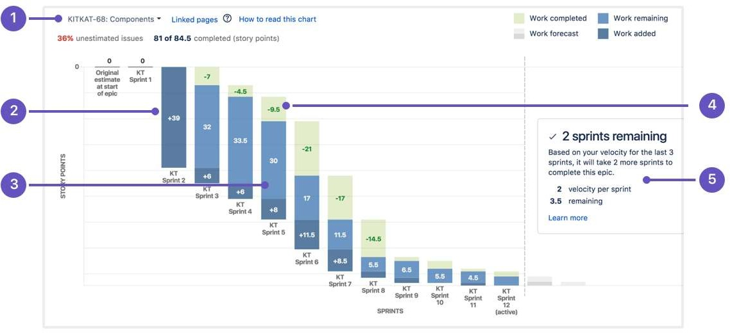

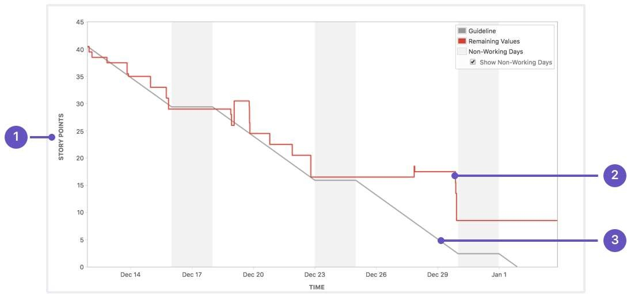

**OCT 22**

**OCT 19**

**OCT 15**

**OCT 7**

**SEP 30**

**SEP 17**

**SEP 14**